**international communications**

**30-day media report – Research article**

**Original paper:** Random fractal-based computational design of an ice-ray (IR) lattice shell structure

**Journal:** Frontiers of Architectural Research

**Authors:** Iasef Md Rian

**Date and place published:** [Volume 13, Issue 2](https://www.sciencedirect.com/journal/frontiers-of-architectural-research/vol/13/issue/2), April 2024, Pages 406-424

**DOI:** <https://doi.org/10.1016/j.foar.2023.12.009>

**Title of press release:** Ice-ray patterns: a rediscovery of past design for the future

**Date Published:** 19 March 2024

**URL:** <https://www.xjtlu.edu.cn/en/news/2024/03/ice-ray-patterns-a-rediscovery-of-past-design-for-the-future>

**Total number of unique readers of the media outlets that picked up the article per month:**

13,907,898

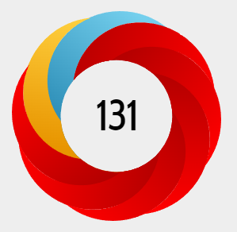**Altmetric score:**

**In the top 1.6% of all research outputs (approximately 26 million) scored by Altmetric.**

The Altmetric Attention Score for a research output provides an indicator of the amount of attention that it has received. The score is derived from an automated algorithm, and represents a weighted count of the amount of attention we've picked up for a research output.

**Number of media outlets that picked up the media release (excluding Chinese outlets):**

**53**

**Languages the article has been translated into (not including Chinese):**

Spanish, German, French, Hebrew, Romanian, Polish, Italian

**Number of media outlets that picked up the media release by country (not including China)**

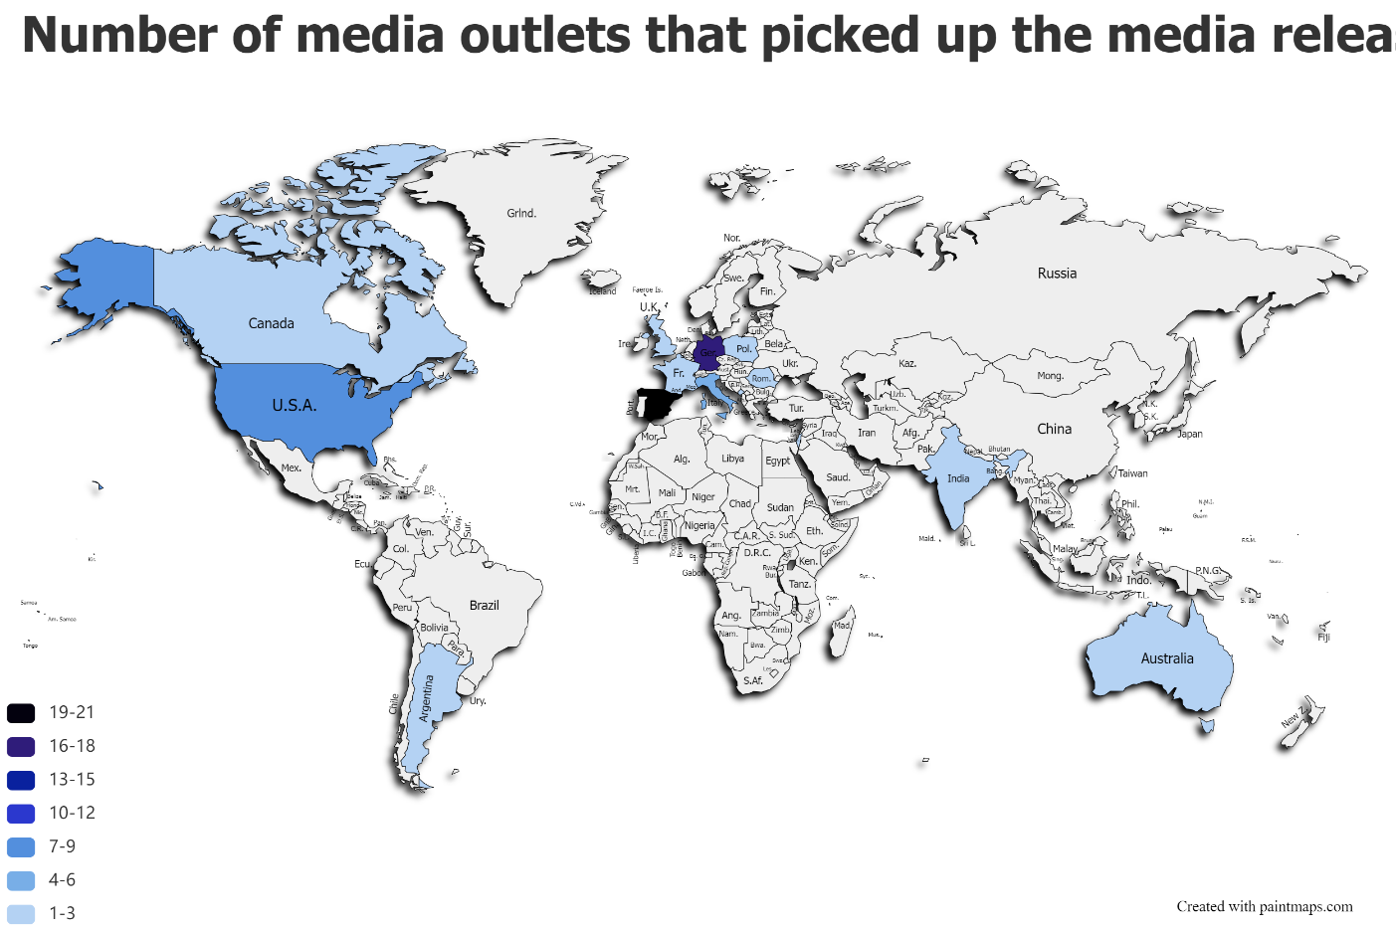

**Advertising value equivalency* (USD)**

**$436,941.23**

*Advertising value equivalency (AVE) is used to measure the dollar value of media coverage. AVE measures the size of the media coverage, the space it was put, and calculates the advertising rate for a similar ad.

Thanks for your support and we look forward to working with you again!

The International Communications Team